* **Destructing** **arrays** creates new variables, and use assignments to set their values to specific elements of an arrays.

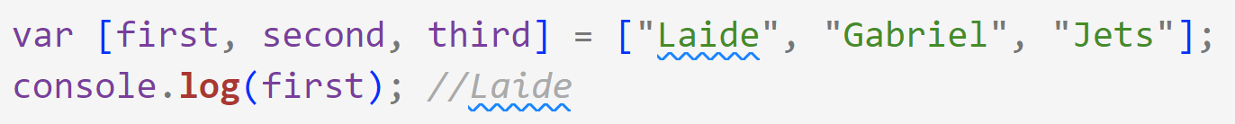

* **Destructing** is not allowed to make the variable names to which to apply the destructing as numbers, it will raise an error.



* **Destructing** allows using default values for the cases in which undefined values are returned.

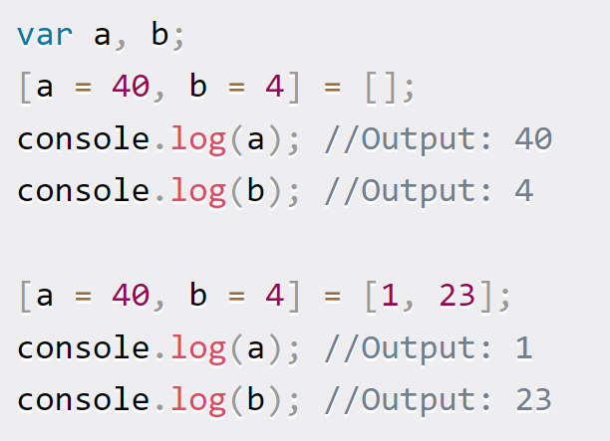

* **Destructing** allows referring to variables including the variables in the same array.

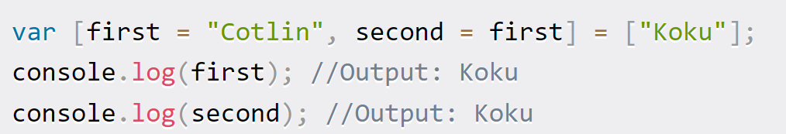

* **It** allows skipping some array elements by leaving its place empty.

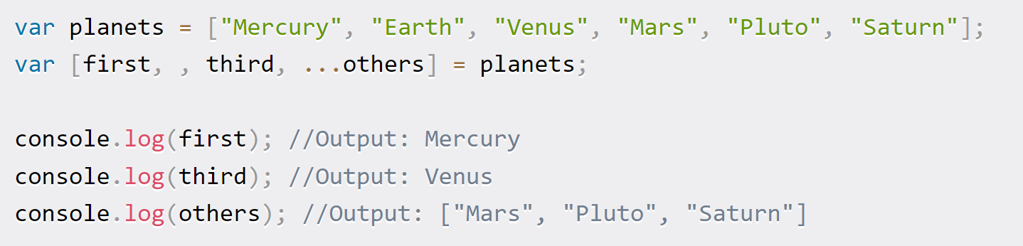

* **It** allows destructing array many times in the same line with different formats.

